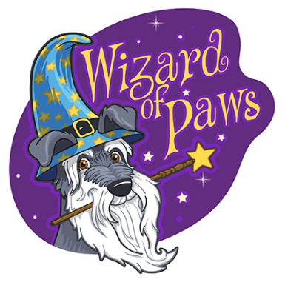
How to Prepare for Class

To get the most out of the program, you will need;
- Food/water bowl for your dog
- Bed or blanket for your dog
- 6-foot nylon leash and walking equipment
- Your dog’s favourite tug toy
- A lot of soft and smelly pea-sized treats (boiled chicken breast, hot dogs, Freshpet, Rollover dog food roll, liver bites)
- Indoor/clean shoes
- Masks
- Your dog’s vaccination records

Class information:

Location: 7 James Street, Georgetown

Length: 6 weeks

Program: Flying Monkeys Pet Manners (Private)

Cost: $360 plus tax

Important:

- We recommend that you don’t feed your dog before class.
- Please pick up after your dog and potty your dog before entering.
- We will notify you in advance if class is cancelled in the event of bad weather and a make-up lesson will be in place.
- Please note that if you miss a class, or are late, we are not to be held responsible for a refund or made up time.
- We do not permit the use of prong, choke, or aversive equipment while attending our training classes. Please contact us for equipment recommendations.

